One Day Shipping

Final Report

Matt Farrell - B00625174

Johna Latouf - B00698246

Orjan Monsen - B00697153

Robert Tracey - B00699803

*December 6th, 2016*

Table Contents

**Project Development Overview****2**

**Project Structure****2**

Level Scripting with Scriptable Objects 2

Managers and the Game Loop 3

**Graphical User Interface****4**

**Environment****6**

The Downtown Core 7

The Suburbs 7

The Plateau 8

**Artificial Intelligence****8**

Enemy Spawning and Placement 8

Dogs 9

Postmen 9

Cars 9

**Original Art Assets****10**

Character Models 10

**Performance and Optimization****10**

**Post-Mortem****11**

Challenges 11

Future Work 11

**Appendix A: References****12**

**Appendix B: Environment Figures****13**

**Appendix C: Project Management - Asana****15**

**Appendix D: Version Control - Github****16**

**Appendix E: Blender****18**

# 

# 

# Project Development Overview

*One Day Shipping* began development on October 1st with an ideation session and project structuring meeting. At this meeting, our team began brainstorming the concept of our game, as well as the development tools that we would use. We chose to work using the agile methodology, and structured our project development into four sprints. To track our work, we used the project management tool Asana (Appendix C-1), and hosted our version control via Github (Appendix D-1). Github desktop clients were used to manage code versioning.

Our first brainstorming session was driven by our previous experiences in game development as well as our personal preference in games. From this brainstorming, we latched on to three key ideas for our project:

1. The game would emphasize extraordinary movement around a world to complete a mundane task.
2. The game would be narrative driven. The gameplay mechanics and challenges we introduce in our game would be determined by the narrative, and not vice versa.
3. The game would be fast both in terms of movement speed and level progression.

From these insights, we developed the idea for *One Day Shipping*, the story of an unfortunately lanky delivery man trying to do his job. The choice for making our player a delivery man was due to the simplicity and repetition of the task, and the idea that delivery people must deliver the mail no matter the weather or circumstance. Further, the choice of giving the player a mundane profession meant we could break up the narrative into chapters reflecting the five day work week.

# Project Structure

## Level Scripting with Scriptable Objects

Our project uses the Unity Scriptable Object structure to define the content for each level. A scriptable object is a data structure in Unity that can be stored as an asset, while also containing serialized data that we can instantiate into the scene, or reference from other game objects. Our game uses a *Level* Scriptable Object that contains the following data:

**Mission Data:** this section includes mission duration, number of packages to deliver, the mission’s background music, and a list of locations for getting and delivering packages.

**Enemy and Prop Spawning:** Each of the game’s enemy types are spawned into a pool at the beginning of a mission. This allows us to reuse the enemies instead of re-instantiating them.

**In-Game Dialogue Events:** Each mission has a number of dialogues that are triggered by different events in the scene. For instance, in the first mission, upon delivering your first package you receive a congratulations from your coworker. Each dialogue event has a list of lines, whether the game world pauses during dialogue, a timer for how long the event lasts, and whether the event needs to be confirmed by a button press.

In order to create the logic for each mission, we extend the *Level* Scriptable Object with a new script for each day. For instance, the script *Monday* is an extension of the *Level* class that contains the mission logic for the first day. Each extension overrides an iterative function *RunLevel* which is triggered by our *LevelManager* singleton as a coroutine. Each level calls back to the *LevelManager* singleton to perform common operations like showing dialogue, avatars, or waiting for button presses. The levels also reference the *GameManager* singleton to check for when the level win state has been reached or time has run out. Upon level completion, the coroutine is terminated.

Each *Level* script can also hold additional data pertaining to the game mechanics of the corresponding level. For instance, the third level uses environmental hazards in the form of a storm that are unique to that level. This system is spawned into the scene via the *Level* script, and managed from this script as well.

## Managers and the Game Loop

The core structure of our game progression is handled by the *LevelManager* and *GameManager* singletons, each persisting between scene changes. The *LevelManager* contains functions for level progression. It is triggered by the *GameManager* to begin a coroutine that takes us through the main loop of the game.

Each level of the game is made up of three scenes: *CutScene*, *InGame*, and *Results*. These scenes are reused for each level, with only the content defined by the scriptable objects changing per level.

The *CutScene* scene plays a chunk of narration defined by the *CutScene* scriptable object. The scene is loaded by the *LevelManager* at run time if it is not already loaded. The *LevelManager* then triggers the *CutScene* object’s coroutine.

After the *Cutscene* has finished, the *LevelManager* loads the player into the *InGame* scene, where our game world is located. The game world contains a number of predefined paths and pickup locations where the enemies and packages will be spawned. This data is found on our *Level* scriptable object and happens on awake.

After the player has progressed through the mission, and the in-game timer has run out, the *LevelManager* does a final transition to the *Results* scene. Here, score tallies are tabulated for packages delivered and destroyed. Each of these statistics, as well as other game states, are contained in the *GameManager*. If the player has completed the level, they will be given the option to continue directly onto the next. When we progress to the next level, a pointer into a list of levels on the *GameManager* is incremented, and the *Level* and *CutScene* scriptable objects for that level are loaded from the *Gamemanager* into the *LevelManager*.

# Graphical User Interface

The main menu is the first scene that is loaded when the game is started up (Figure 1). This menu is completely contained within a scene called *FrontEnd*. The main menu has six options: *New Game*, *Continue*, *High Scores*, *Level Select*, *Controls*, and *Exit*. The *New Game* option starts the game from the first cut scene, while the *Continue* option starts the game at the last level played. When any of the three menus – *High Scores*, *Level Select*, or *Controls* – are selected, a new menu is displayed that corresponds to the option selected. This is done by setting the current main menu disabled and enabling the menu that corresponds to the option that was selected. The exit option simply exits the game.



Figure 1: *Main Menu*

The *High Score* menu displays the highest score that has been achieved for each level as well as the name of the user who set the score (Figure 2). The scores are saved on the user’s machine locally using the PlayerPrefs feature made available by Unity. That means if the user exits the game, and starts it again, the high scores will persist.

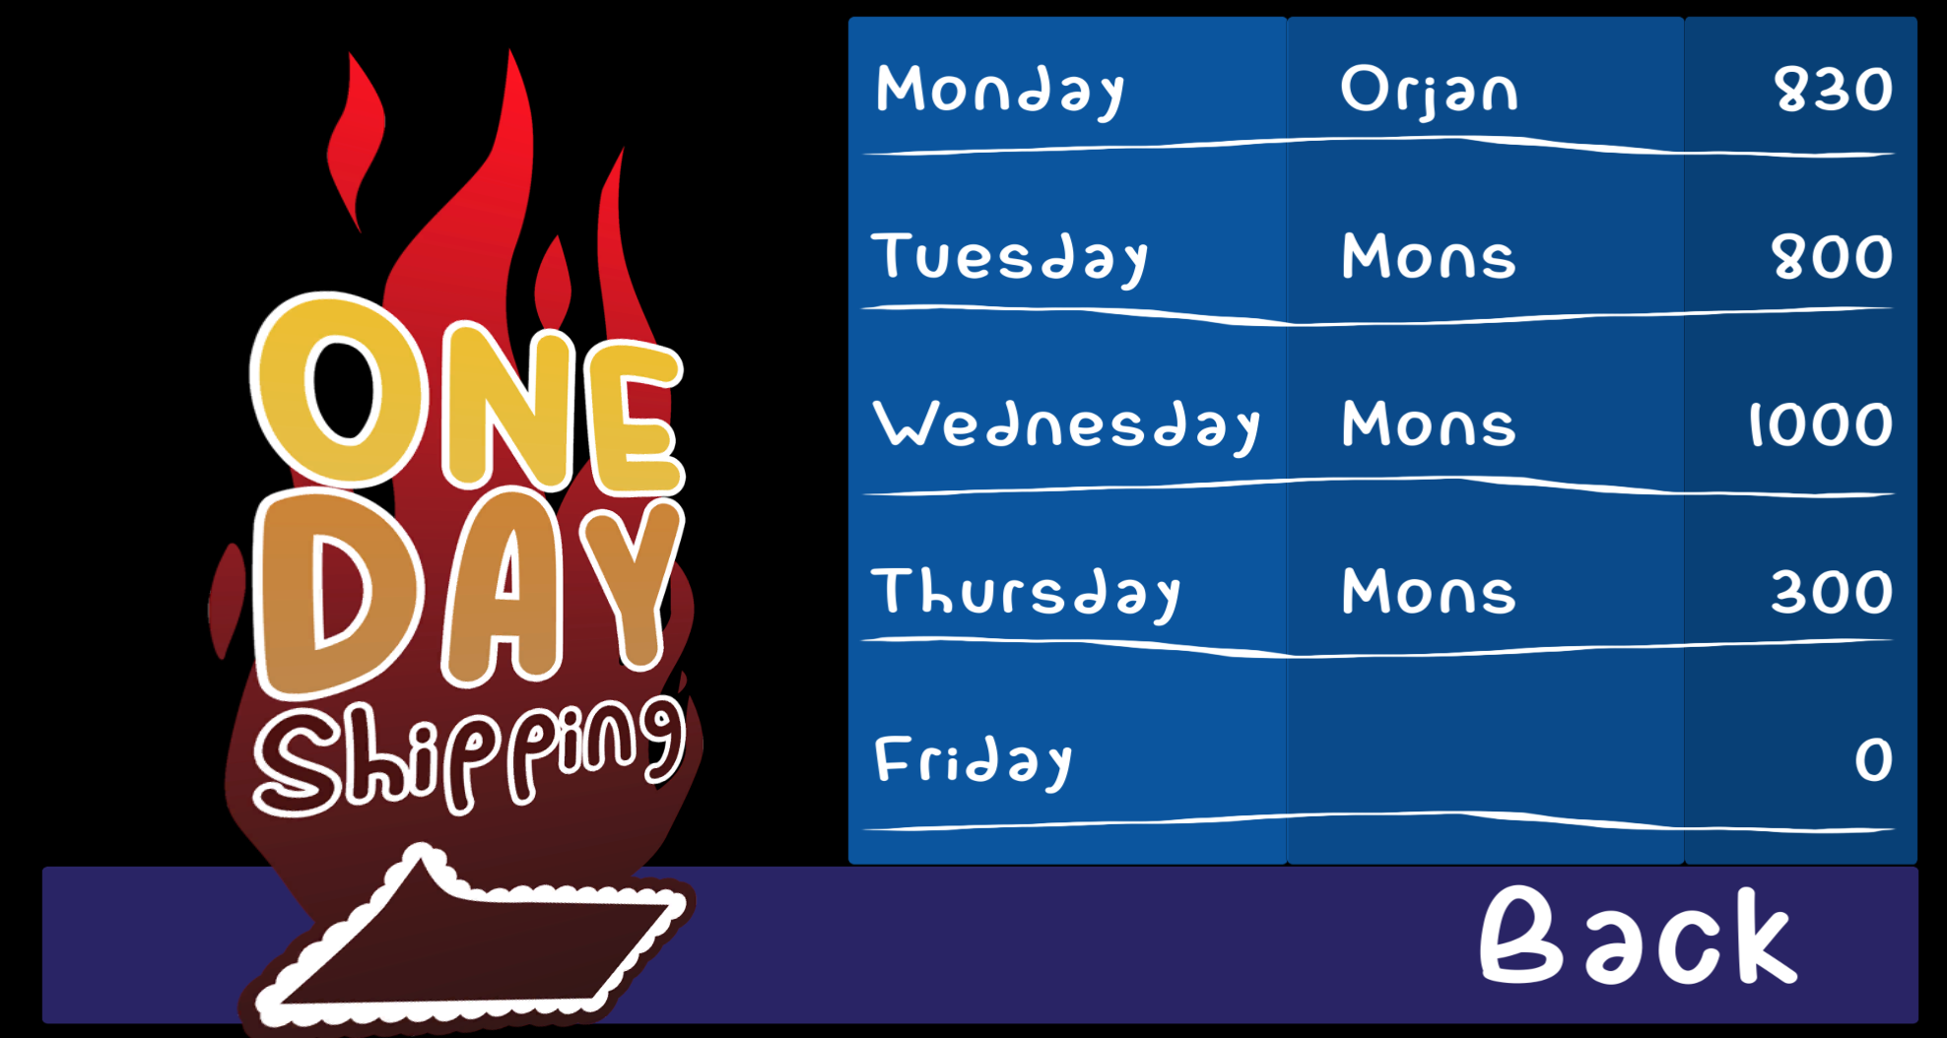

Figure 2: *High Scores*

The *Level Select* menu displays the playable levels of Monday through Friday. Monday is the only level that is unlocked when the user is new to the game, the levels that are locked are darkened. To unlock the rest of the levels, the user must play through and complete them. When they are unlocked they get colored in red (Figure 3).



Figure 3: *Level Select* Locked / Unlocked

The *Controls* menu plays a short video with key overlays that demonstrates how to control Larry (Figure 4). The video was recorded using QuickTime and added to the project through use of movie textures. The QuickTime plugin must be installed in order for the video to play in the *Controls* menu.

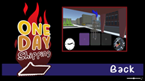

Figure 4: *Controls*

The in game Heads-Up Display (HUD) consists of four main components: the mini-map, clock, directional arrow, and package delivery counter (Figure 5). The mini-map is an orthographic camera positioned in the bottom right corner of the screen, its view is fixed directly above the player facing downward. It gives the player a top-down display which can be useful for seeing around corners. The mini-map also shows the player’s position, cars, drop off locations, and pick up locations.

The clock is positioned in the bottom left corner of the screen. It displays how much time is left in the work day. The work day starts at 9:00am and ends at 5:00pm.

The directional arrow is positioned above the player’s head. It points towards the current goal, whether it be a pick up location or drop off location.

The package delivery counter is positioned in the top left corner, it simply displays the amount of packages delivered over the amount of packages that needed to be delivered.

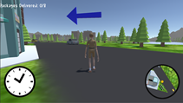

Figure 5: HUD

When the escape button is pressed in game, the game is paused, and the *Pause Menu* is displayed (Figure 6). The *Resume* option exits the pause menu and continues the game. The *Main Menu* option returns the user to the *Main Menu*. The settings option allows the user to adjust the master game volume. The *Quit* option simply quits the game.

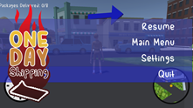

Figure 6: *Pause Menu*

In-level dialog is displayed via a popup window (Figure 7). The window contains a sprite of the character who is talking. The game also pauses and waits for the user to select the continue button.

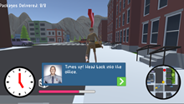

Figure 7: In Game Dialogue

At the end of each level you are presented with the stats from your performance. If you set the high score for that level, you are notified, and prompted to enter your name (Figure 8).

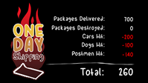

Figure 8: *Results* and *New High Score*

# Environment

The game environment was designed and prototyped during our first sprint (Appendix B-1). We built the environment from scratch using the Unity terrain tools to make it feel original and gain full control of the development and design. We started by creating an empty terrain object in the scene, setting its size to 500 x 290, and then separating the three main components of the environment by a river. We then moved on to create the mountains that surround the world by raising the terrain edges.

We designed and applied four materials to the terrain to distinguish parts of the world from each other: the roads, mountains, grass, and parking lot textures. The roads need to be symmetrical to create a true city feeling, so we exported the terrain into *Gimp* and used the terrain splat maps to automatically paint the roads for us, before importing it back into Unity again. Splat maps use RGB values to determine which texture gets applied to which quad of the terrain mesh, where each quad is represented by one pixel on the splat map.

The purpose of the mountains are to avoid having the player go outside of the world, which gives us full control of possible player movement in the scene. From an artistic perspective, the mountains also create a strong contrast to the grass and the river.

The mountains at each endpoint of the river are designed in such a way that the player can’t ever see the end of the river, which from the player’s perspective makes it look like the river continues outside of the scene, and that there’s another world on the other side of the mountains.

We chose to distinguish the parking lots from the roads to avoid confusion for the player in terms of where there will be driving cars and where there will be stationary cars in the scene.

The environment consists of three main regions separated by a river and connected with bridges: *The Downtown Core,* *The Suburbs*, and *The Plateau*.

## The Downtown Core

When constructing the Downtown Core, we used our own city experiences and observations to define the downtown atmosphere. There are many tall buildings, restaurants, stores, gas stations, parking lots, sidewalks, supermarkets, and offices to make the downtown area as realistic as possible (Appendix B-2). Due to the time constraints within this project, we decided to use the city assets from the *Stylized Simple Cartoon City Package* (Appendix A-9) and the *Simple Urban Buildings Pack 1* (Appendix A-8) in the Unity Asset Store. Since we decided to only have one big game environment for all levels, we chose to keep the style Low Poly to decrease the number of vertices drawn on the screen per frame, ultimately resulting in an increased frame rate per second.

While constructing the city in the scene, we built a few unique city blocks, duplicated them, spread them around, and then tweaked the duplicates enough to make them feel different from one another. This sped up the creation process significantly.

## The Suburbs

The western part of the Suburbs still has some city design elements to it, as the city slowly degrades into a suburban area from west to east (Appendix B-3). The construction of the neighbourhoods included a replication process of real suburban areas, resulting in a realistic rural area which adds to the reality and logical sense of the game. There are some nature elements in the Suburbs such as trees, parks, lakes, and forests.

When constructing the Suburbs, we perfected the prefabs of each house and placed them in the scene while also keeping in mind that a neighbourhood does not always follow a perfectly symmetrical pattern, but rather a more random distribution when it comes to angles and housing placements. We used duplication techniques to place the prefabs in the scene, while also tweaking the y-rotation to break symmetry.

## The Plateau

The design process of the Plateau consisted of using the *Paint Height* terrain tool in Unity (Appendix B-4). The tricky part was creating a steady road climb that wasn’t too steep for the player to climb up, and this was solved by painting the height of the mountain one small layer at a time. This resulted in two unique winding roads which leads to the top, a design that replicates how roads are built on large mountain climbs in real life. We then used the terrain smoothness tool to generate a more rounded mountain eliminating sharp edges. We also painted the mountain with a mixture of the grass and mountain textures in an attempt to differentiate between the plateau surface and the sharp cliff faces. The Unity Asset Store did not have any large, evil-looking office buildings, so we ended up designing the Postal Service Headquarters in Blender (Figure 9, Appendix A-4).

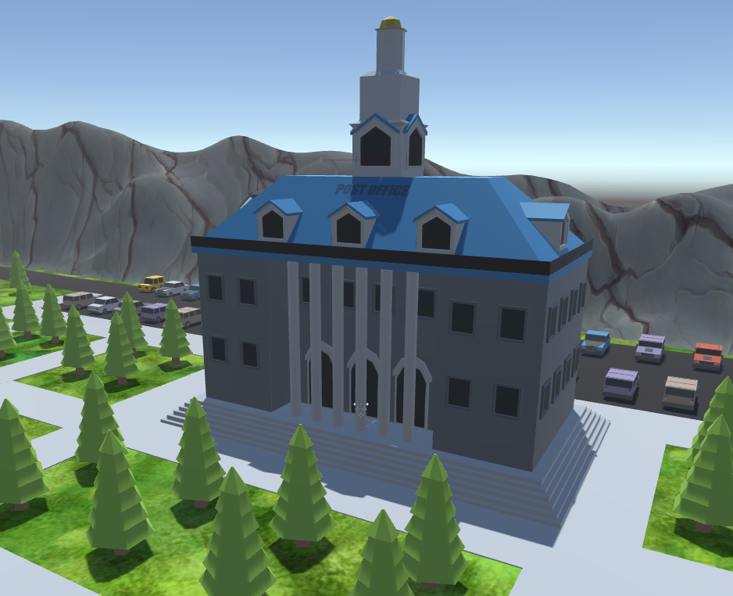

Figure 9: Postal Office Headquarters

# Artificial Intelligence

## Enemy Spawning and Placement

The number of enemies required to fill a world of this size is impractical, so *One Day Shipping* employs a location-based spawning system. The terrain is split up into circular sections which are stored in pool objects. When the player object enters a particular section, enemy objects spawn on that section's respective path or at specified spawn points. The number of enemy clones is set on the *Level* scriptable objects. Enemies that require curved path-driven movement are placed on a curve generated by a modified version of *iTween* (Appendix A-6). The original iTween script includes inefficient and unnecessary array copying which has been removed to improve frame rate. Objects are spawned along paths at equal distances apart. They then move along these paths by a small percentage at each call of the Update function.

## Dogs

The dog enemies operate using a simple range and chase mechanic. Each dog has a radius attribute and a center point that form a circular range. The dog runs to the edge of this circle, turns at a random angle, and runs to the other edge. If the player object steps into this range, the dog enters a chase state and runs towards the player. When the distance between the dog and player drop below a specified threshold, the dog enters an attack state. This causes the attack animation to trigger. During the attack state, the dog also applies damage to the player score and the package, if it is present, with a slight time delay between hits.

## Postmen

The postman enemies employ a radius and chase and attack states similar to those of the dog, but the postman must also walk along a path. The center for the postman's circular range is set by the postman's current position on the path. In his chase state, he walks off of the path, towards the player. When the player is no longer in range, the postman walks back to his place on the path. A second, wider radius is used to trigger the postman's projectiles. These projectiles can be turned on and off globally by the *LevelManager*. The postman turns towards the player and throws projectiles when the player steps within this wider radius.

There is a set of postmen situated around the post office that remain stationary without following a path. These postmen have a much smaller chase radius. Their center points are fixed, and use the same projectile mechanism as the path-following postman.

## Cars

The cars do not leave their respective paths, but they are designed to avoid driving through each other using collision detection with a collider placed on the front bumper (Figure 10). Collisions between the player and cars damage game score and packages. They also apply a force to the player, determined by the direction vector between vehicle and player, tossing him up and opposite the car. The force varies based on the player's motion and speed.

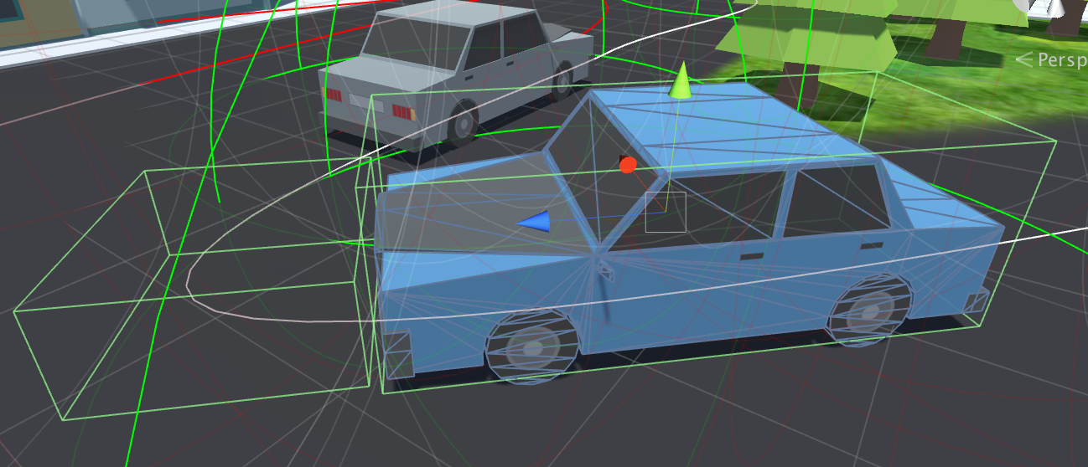

Figure 10: Car Colliders

# Original Art Assets

## Character Models

Base meshes for Larry Noodleman and the postman were generated using the free software MakeHuman (Appendix A-3). These models were modified in Blender to achieve the look required for the game. The rigs and animation for these characters were generated using Mixamo (Appendix A-5). The *One Day Shipping* Boss and Dispatcher characters were also modelled using a combination of Makehuman and Blender (Figure 11). These characters are not rigged, as they are only used in 2D images. The images were further edited using image editing software.



Figure 11: The Boss and The Dispatcher

# Performance and Optimization

Creating an open environment for a game world requires a large number of game objects to populate the scene, and a dense terrain mesh to create the required texture resolution at the scale of the player. These elements result in a large computational overhead on both the CPU and GPU. To accommodate for this overhead, and keep our game within a reasonable frame rate for the player’s experience, we utilized a series of performance-enhancing techniques.

**Static and Dynamic Batching:** the overhead associated with establishing a draw call in the GPU can be mitigated by batching meshes together. Meshes that use a similar material can be combined at run time into a single mesh, resulting in a single draw pass for the GPU instead of an individual pass per mesh. There is a drawback for the CPU on batching, as the CPU must combine meshes, but the GPU side of execution tends to have a larger frame rate deficit. To take advantage of static batching, all static objects in our game environment were toggled to static.

**Baked Lightmaps:** Lighting calculations are typically expensive, depending on the number and types of lights used in a given scene. By baking lightmaps we are applying a multiplied texture to the surface of all static lit objects in the scene, meaning that lighting calculations for those objects will not have to be done.

**Baked Occlusion Culling:** When drawing to a screen, the typical order of drawing begins at the camera’s far plane and works in decreasing depth. This results in the drawing of many objects that may be obscured by other objects that are closer to the camera. Unity’s new baked occlusion map system deals with this issue by creating a top-down texture map of the scene that marks which objects are visible to the camera at any given camera position. This allows for the reduction of drawn geometry on screen, especially when the player is within a dense urban area with plenty of occlusion.

# Post-Mortem

## Challenges

As noted above, working in one large level presented a lot of potential for memory and frame rate issues. We were able to pool enemies in a way that allowed for a small number to load based on the player position, and used available techniques within Unity to reduce the number of GPU draw calls.

Additionally, upon first planning our world, we did not correctly estimate the amount of time it would take to create and populate that world. The time it took to populate the world and get back to the development of gameplay resulted in an initial dip in our development velocity.

## Future Work

There are a number of gameplay features we would like to include in the game, but due to time constraints we didn’t have time to implement them. This included power ups that increase the player’s speed, and a shield that protects the player and package from score reduction damage for a short period of time, allowing the player to run through traffic and enjoy the fun of car collisions.

Some environmental obstructions to add would be oil slips and water puddles, which would make the player continue moving forward in the same speed while restricting the player from turning.

We would like to add a larger variety of enemies, including changes to our existing ones. For instance, dogs could be leashed to poles, where the player would trip over the leash and fall down to the ground if he ran into it.. There are also lots of improvements that can be made to the game environment, including city props such as backyard fences, bus stops, traffic lights, and park benches.

# **Appendix A: References**

1. **Low-Poly Corgi:** http://www.blendswap.com/blends/view/79709
2. **Tiger Asset:** https://www.assetstore.unity3d.com/en/#!/content/55797
3. **MakeHuman:** http://www.makehuman.org/
4. **Blender:** https://www.blender.org/
5. **Mixamo:** https://www.mixamo.com/
6. **iTween**: http://itween.pixelplacement.com/index.php
7. **Gimp:** https://www.gimp.org/
8. **Simple Urban Buildings Pack 1:** https://www.assetstore.unity3d.com/en/#!/content/33563
9. **Stylized Simple Cartoon City:** https://www.assetstore.unity3d.com/en/#!/content/50095

# 

# 

# **Appendix B: Environment Figures**

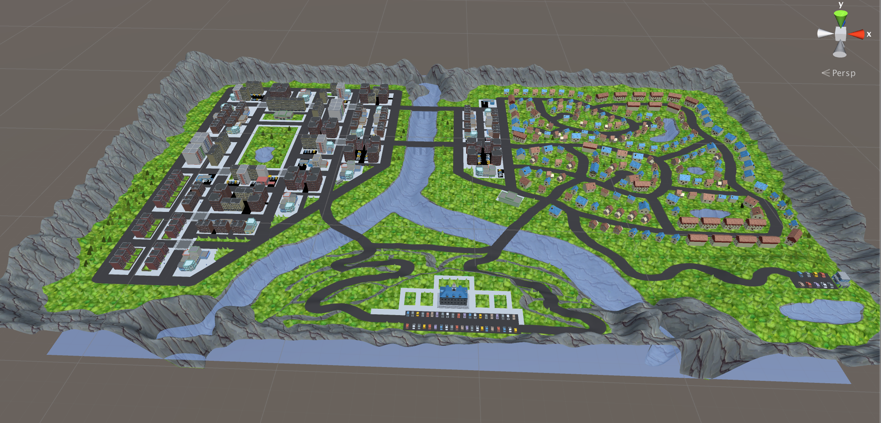

Figure B-1: The Environment

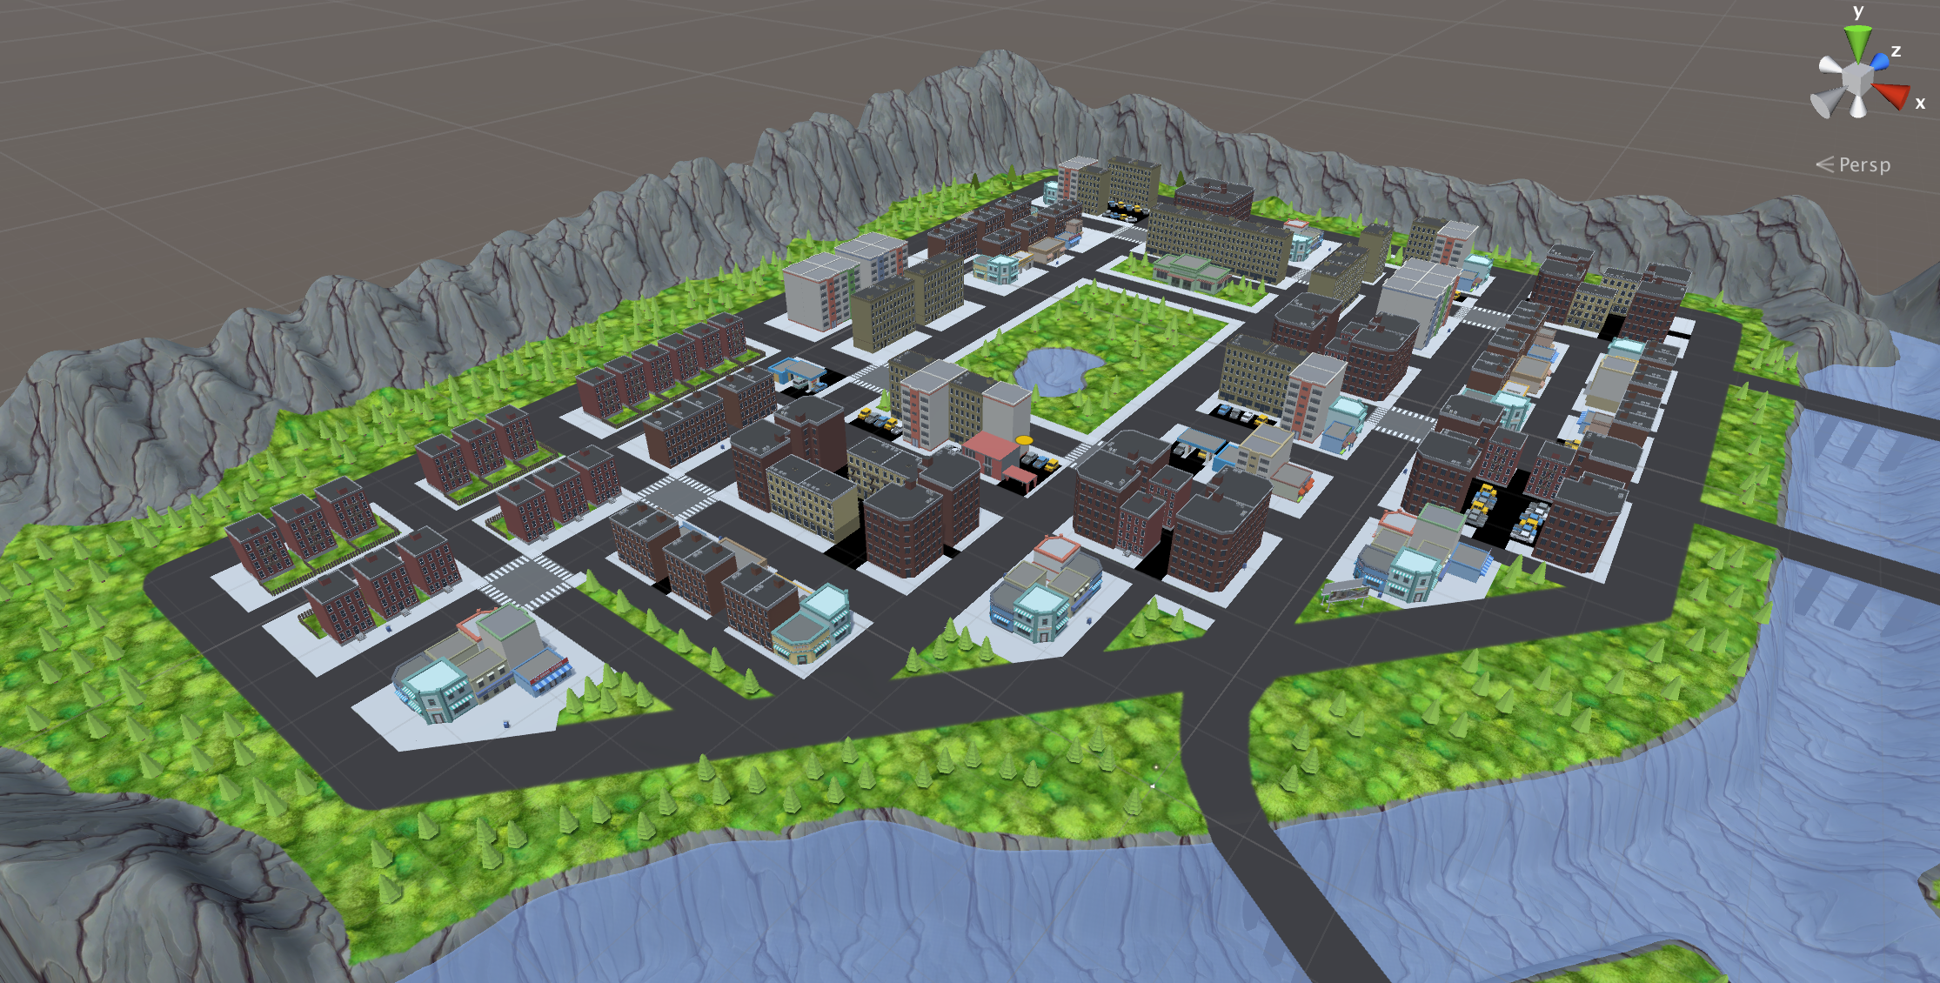

Figure B-2: The City

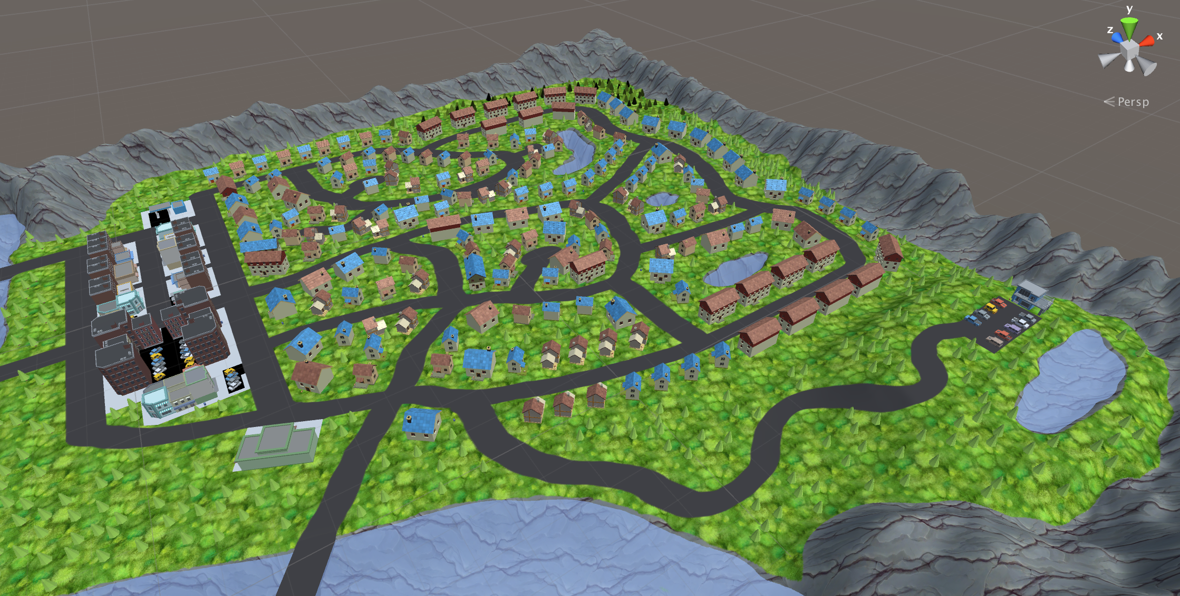

Figure B-3: The Suburbs

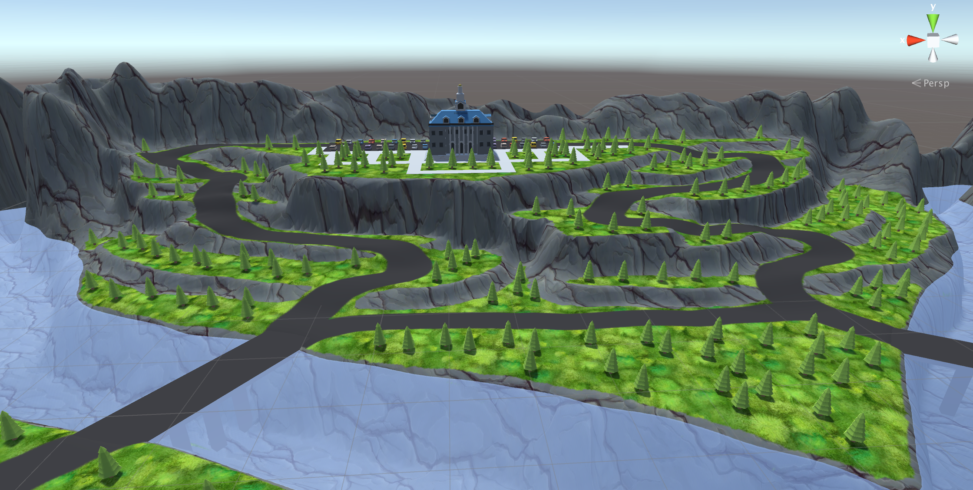

Figure B-4: The Plateau

# Appendix C: Project Management - Asana

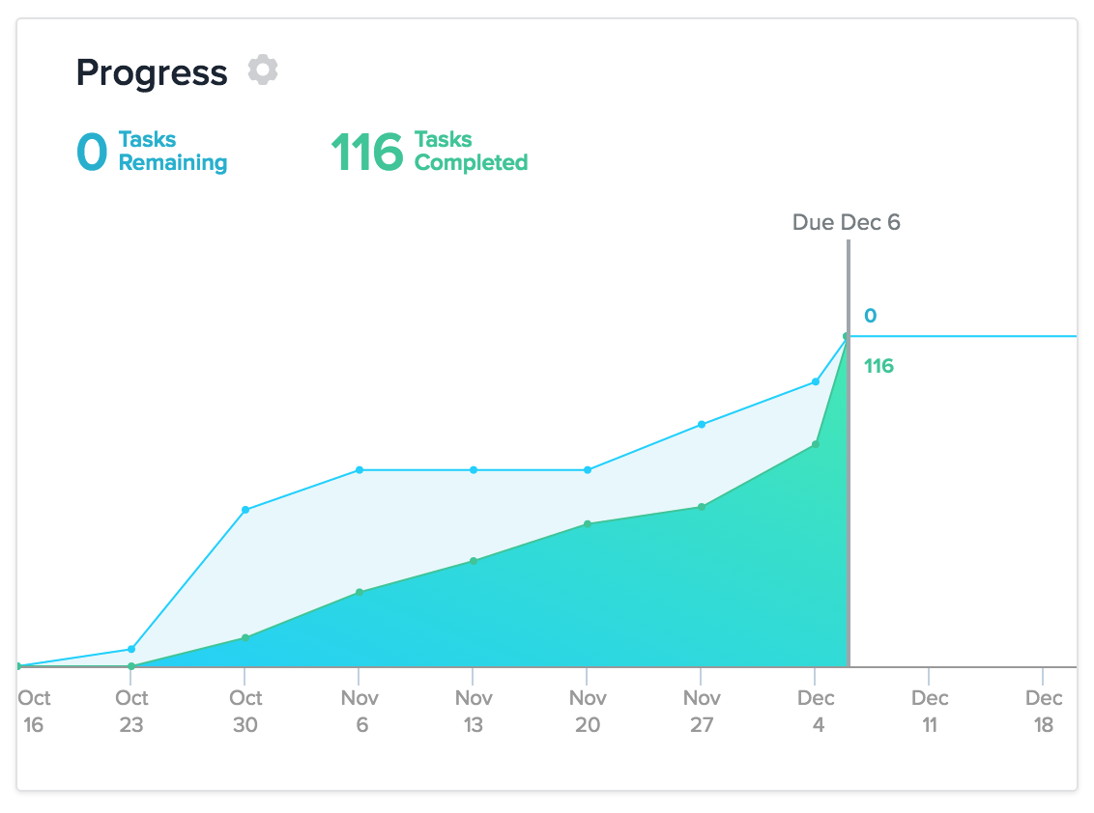

Figure C-1: Team Velocity

<http://app.asana.com>

# Appendix D: Version Control - Github

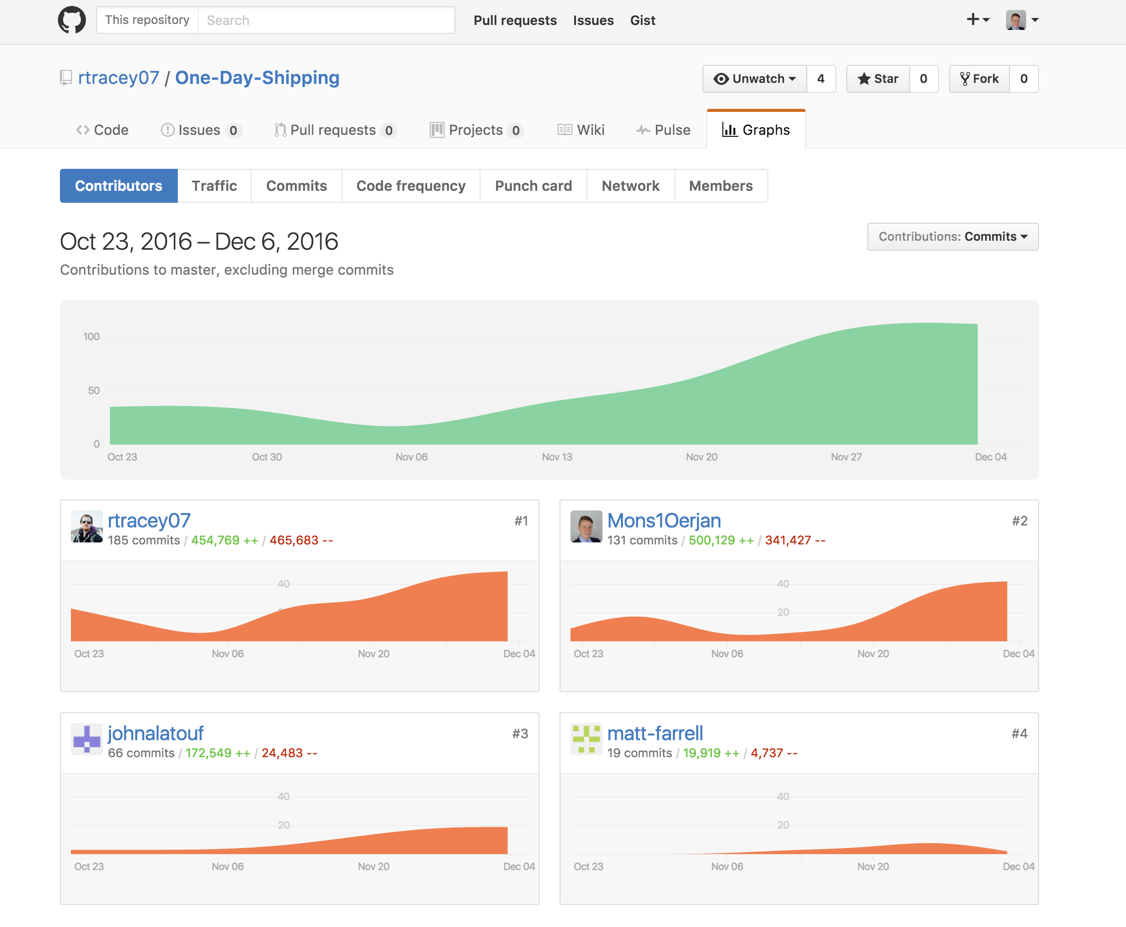

Figure D-1: Github Graphs

[www.github.com/rtracey07/one-day-shipping](http://www.github.com/rtracey07/one-day-shipping)

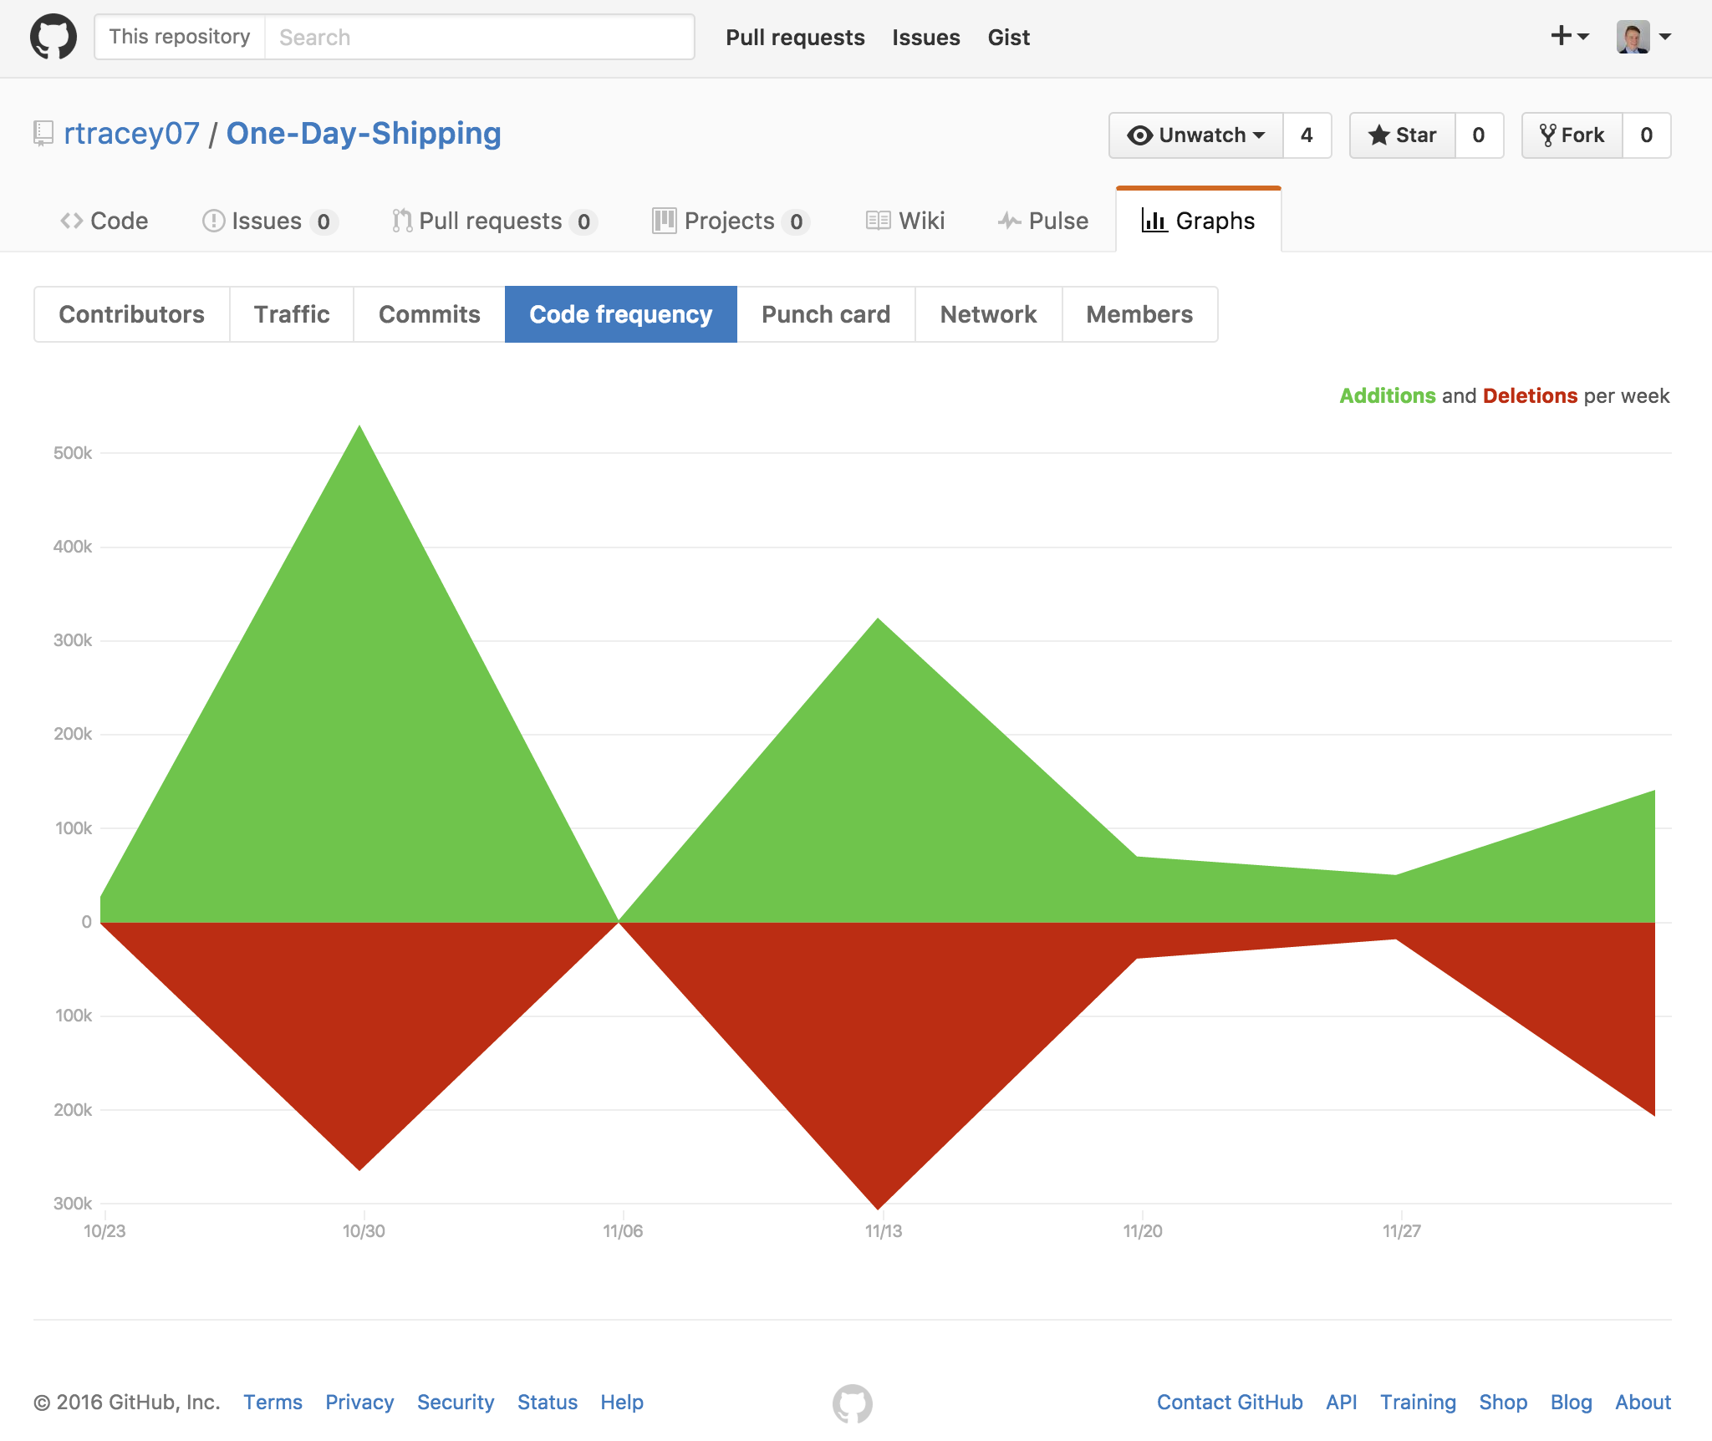

Figure D-2: Github Code Frequency Graph

# 

# 

# Appendix E: Blender

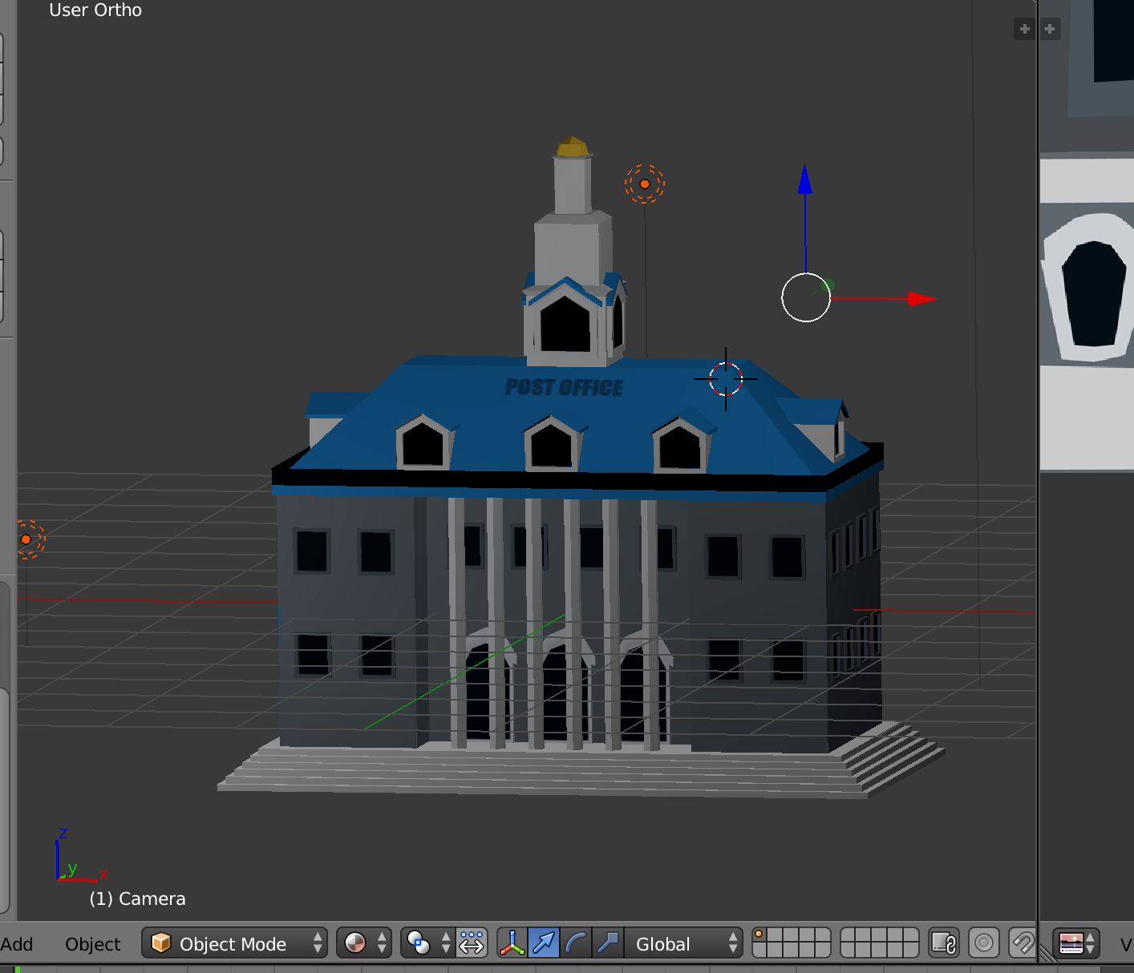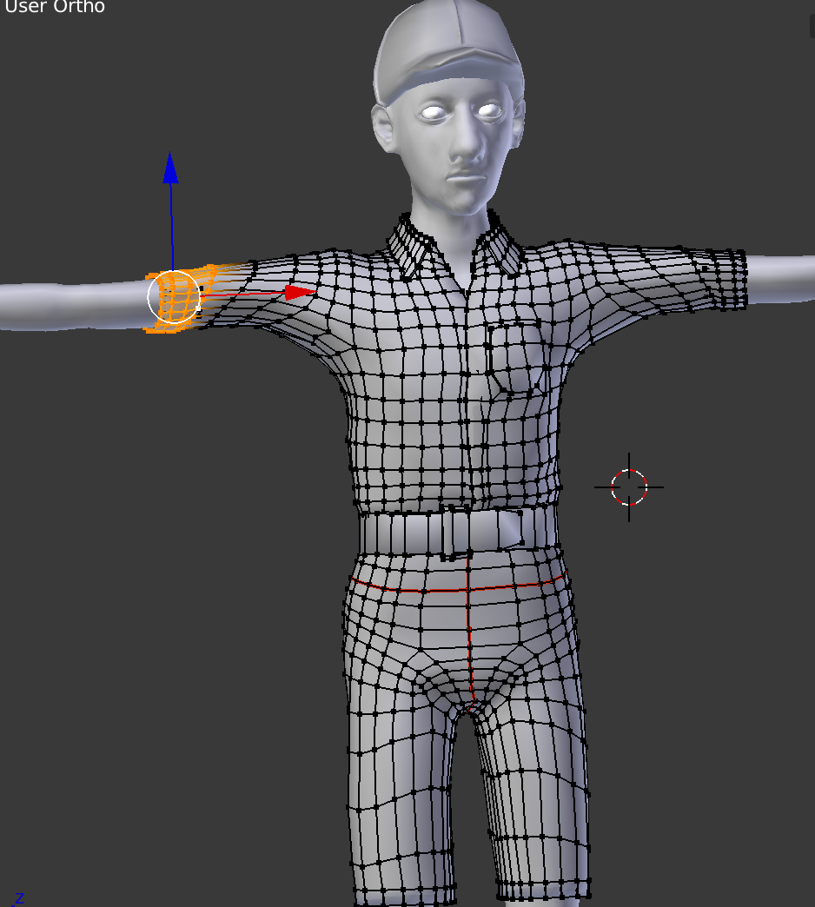

Figure 1: Evil Post Office model Figure 2: Noodleman model

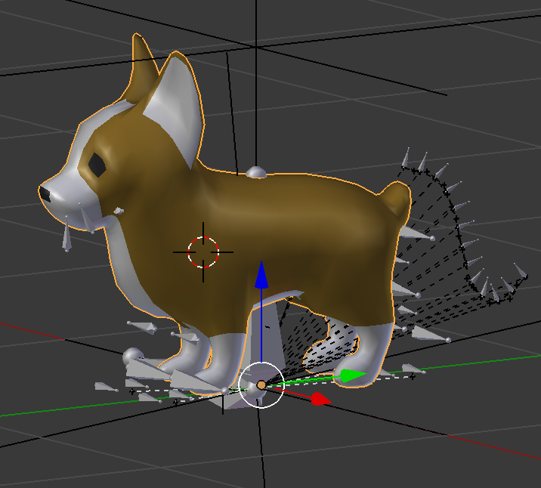

Figure 3: Dog model